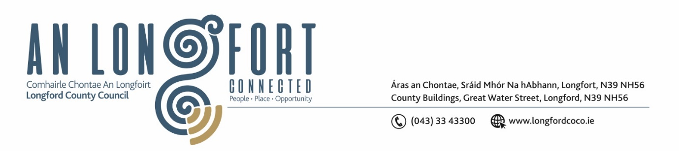

***Please note meeting will be held in the Council Chamber and via Microsoft Teams.***

1 Samhain 2023

**Chuig: Gach Ball don Chomhairle**

A Chomhairleoir,

Iarrtar ort bheith i láthair ag Cruinniú Míosuil Chomhairle Chontae Longfoirt a tionólfar i Seomra na Comhairle, Aras an Chontae, Longford agus via MS Teams are an **Chéadaoin 8ú Samhain 2023 ag 3.30pm** chun gnó a dhéanamh d’réir an Chláir thíos.

You are requested to attend the Monthly Meeting of Longford County Council to be held in the **Council Chamber and via Microsoft Teams** on **Wednesday 8 November 2023 at 3.30pm** to transact business, as set out on the Agenda hereunder.

Mise le meas,

**__________________**

***Claire McNabola***

***Meetings Administrator.***

**C L Á R**

Prayer before meeting.

**Presentation from Waterways Ireland**

1. Confirmation of Minutes:
2. Monthly meeting of Longford County Council held on 11 October 2023 – enclosed
3. Matters Arising.

**3.** Declaration of Interest by Members.

1. To note Management Report – to follow.

**5.** To note adopted Minutes of Corporate Policy Group Meeting held on the

12 September 2023 – enclosed.

**6. Finance and Information Technology**

1. Minutes of Governance SPC meeting held on 17 July 2023 – enclosed.

**7. Housing, Planning, Regeneration & Capital Projects**

1. Minutes of Climate Action & Planning SPC meeting held on 19 July 2023 – enclosed.
2. Consideration of disposal of Property at 5 St Patrick’s Terrace, Longford Town, Co Longford, in accordance with the terms of Section 183 of the Local Government Act 2001 issued on the 20 October 2023 – as circulated.
3. Consideration of disposal of Property at 45 Teffia Park, Longford Town, Co Longford, in accordance with the terms of Section 183 of the Local Government Act 2001 issued on the 20 October 2023 – as circulated.
4. Consideration of Part VIII No. 110 – Solar Powered Lights at Granard Urban Greenway - Report in accordance with Section 179 of the Planning and Development Act 2000 (as amended) and Part 8 of the Planning & Development Regulations 2001 (as amended) – enclosed.
5. Consideration of Part VIII No. 111 – New carpark & safety barriers along the Drumlish to Arvagh Regional Road (R198). Landscaping works around the new amphitheater in Moyne - Report in accordance with Section 179 of the Planning and Development Act 2000 (as amended) and Part 8 of the Planning & Development Regulations 2001 (as amended) – enclosed.
6. Notice of Motions, submitted by Councillors, as listed hereunder

**Councillor Colm Murray**

I call on Longford County Council to initiate a process that will see a town/village plan developed, in conjunction with the local Community, for each village, town and settlement in the County as identified in the Longford County Development Plan 2021-2027. The plans should be in line with the County Development Plan and encompass elements such as active travel, green spaces, better use of derelict sites and any other important developments (business, recreational or accommodation) as identified by the Community, Longford County Council and the local Representatives.

**8. Infrastructure Climate Action & Innovation**

**(a)** Minutes of Infrastructure SPCmeeting held on20 July 2023 – enclosed.

**9. General**

1. Notice of Motions, submitted by Councillors, as listed hereunder

**Councillor Paul Ross**

I call on the Minister for Agriculture, Food, and the Marine to revert to the previous system of CAP farm payments in which the first ANC payment was made in September. The new delayed payment scheme has put undue stress on both farmers and traders alike and has caused serious cashflow issues for the industry.

**10. Correspondence**

1. Correspondence received from Ireland East Hospital Group re. updates on matters relating to St. Joseph’s Care Centre – enclosed.
2. Correspondence received from Department of Agriculture, Food, and the Marine re. Beef Finisher Payment – enclosed.
3. Correspondence received from Department of Education re. School Transport Scheme – enclosed.

**11. Votes of Sympathy**